MASTERCLASS 1
SCALE UP LEADERSHIP
Workbooks by
ART OF SCALE

SCALE THYSELF

W O R K B O O K
THE ART OF SCALE IN THE AI EA

JASON GOLDBERG

For participants in the Founders at Work Programme.
Proprietary & Confidential

VERSION HISTORY & UPDATES
Version 1.0 | March 2026.
This document will be updated periodically to reflect evolving best practice.


______________________________________________________________________________________________________________________________________________________________________________________________________________________________________________________________________________________________________

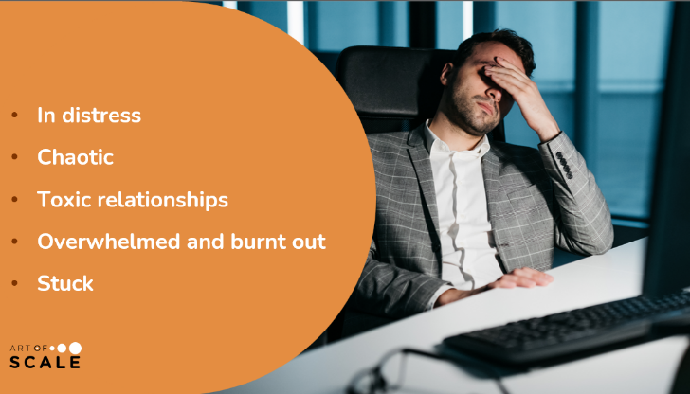
______________________________________________________________________________________________________________________________________________________________________________________________________________________________________________________________________________________________________


______________________________________________________________________________________________________________________________________________________________________________________________________________________________________________________________________________________________________
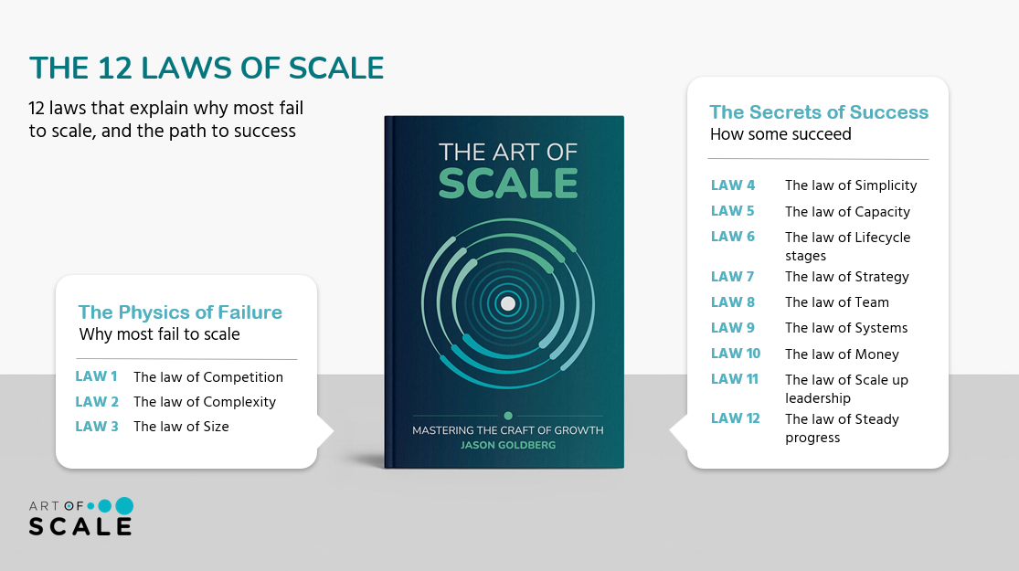

_________________________________________________________________________________________________________________________________________________________________________________________________________________________________________________________________________________________________________________________________________________________________________________________________________________________________________________________________________________________________________________________________________________________________________________________________________________________________

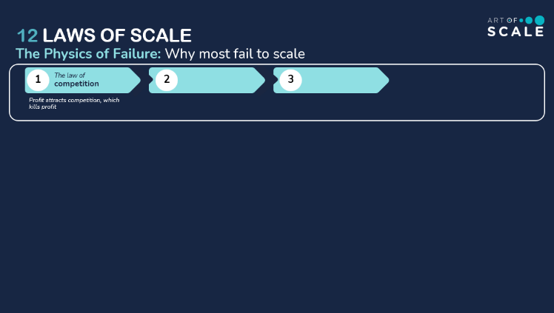
______________________________________________________________________________________________________________________________________________________________________________________________________________________________________________________________________________________________________

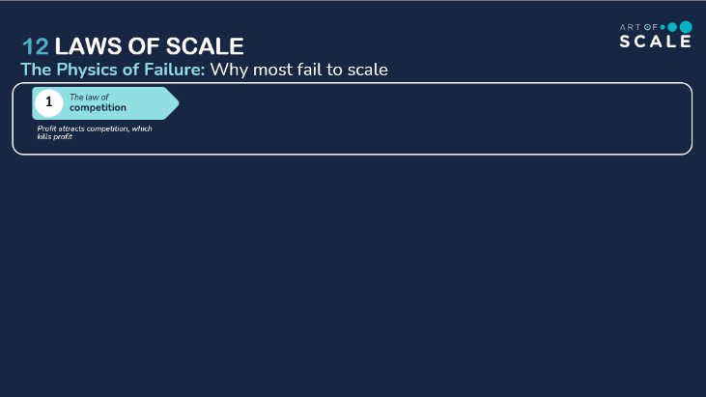
______________________________________________________________________________________________________________________________________________________________________________________________________________________________________________________________________________________________________

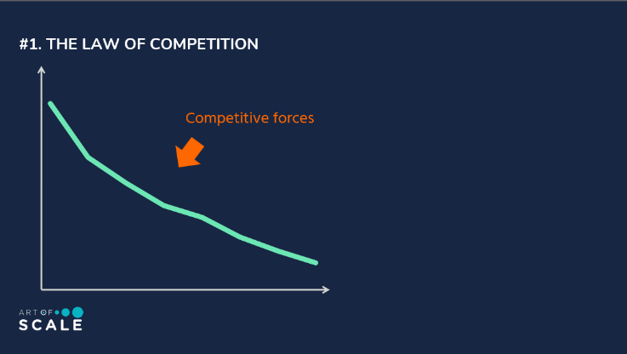
______________________________________________________________________________________________________________________________________________________________________________________________________________________________________________________________________________________________________
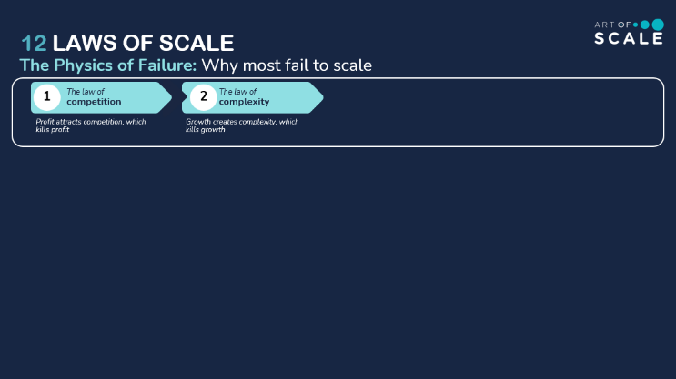
______________________________________________________________________________________________________________________________________________________________________________________________________________________________________________________________________________________________________

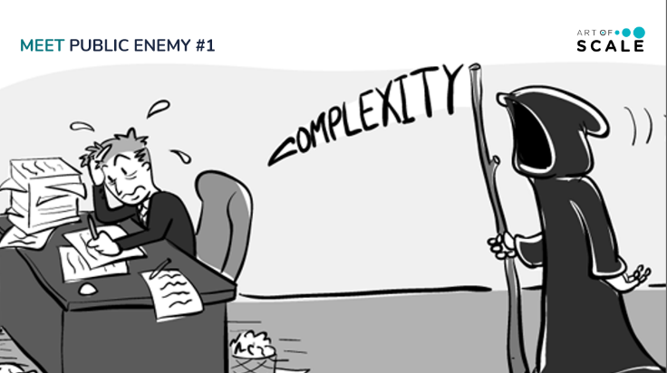
______________________________________________________________________________________________________________________________________________________________________________________________________________________________________________________________________________________________________

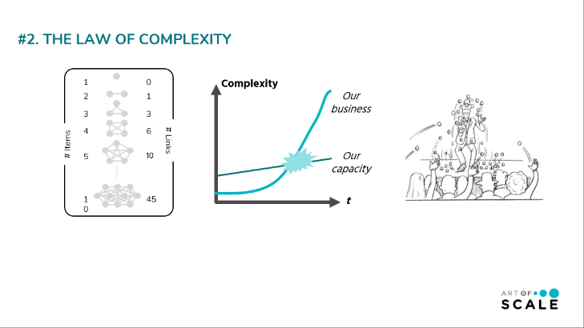
______________________________________________________________________________________________________________________________________________________________________________________________________________________________________________________________________________________________________
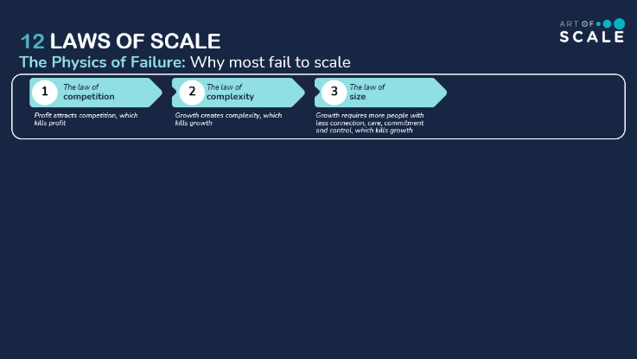
______________________________________________________________________________________________________________________________________________________________________________________________________________________________________________________________________________________________________

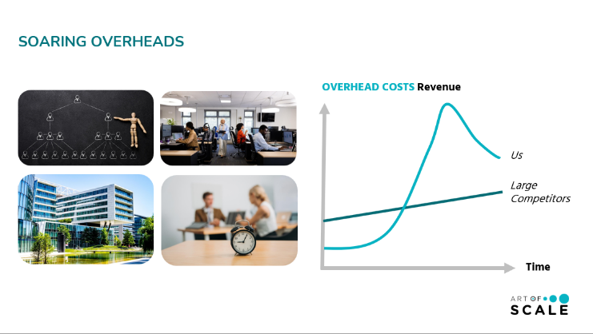
______________________________________________________________________________________________________________________________________________________________________________________________________________________________________________________________________________________________________

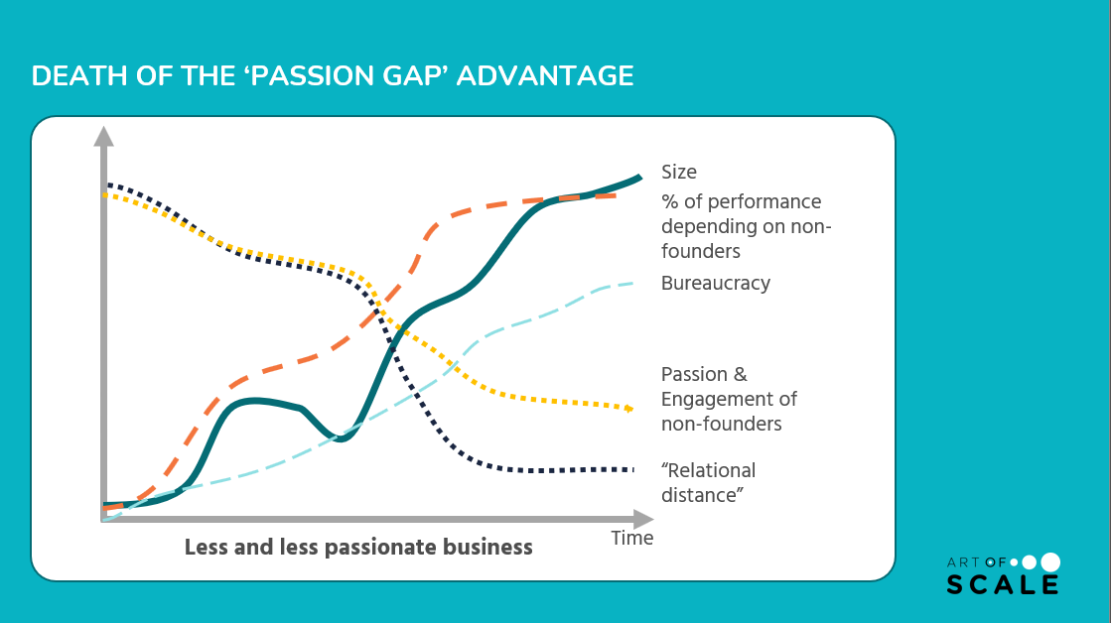
______________________________________________________________________________________________________________________________________________________________________________________________________________________________________________________________________________________________________________________________________________________________________________________________________
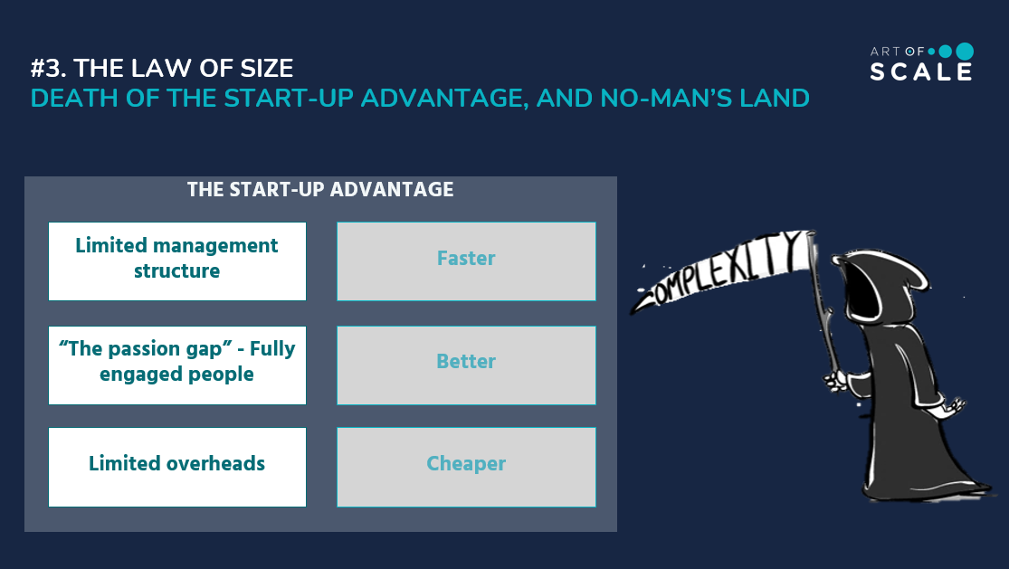
______________________________________________________________________________________________________________________________________________________________________________________________________________________________________________________________________________________________________________________________________________________________________________________________________

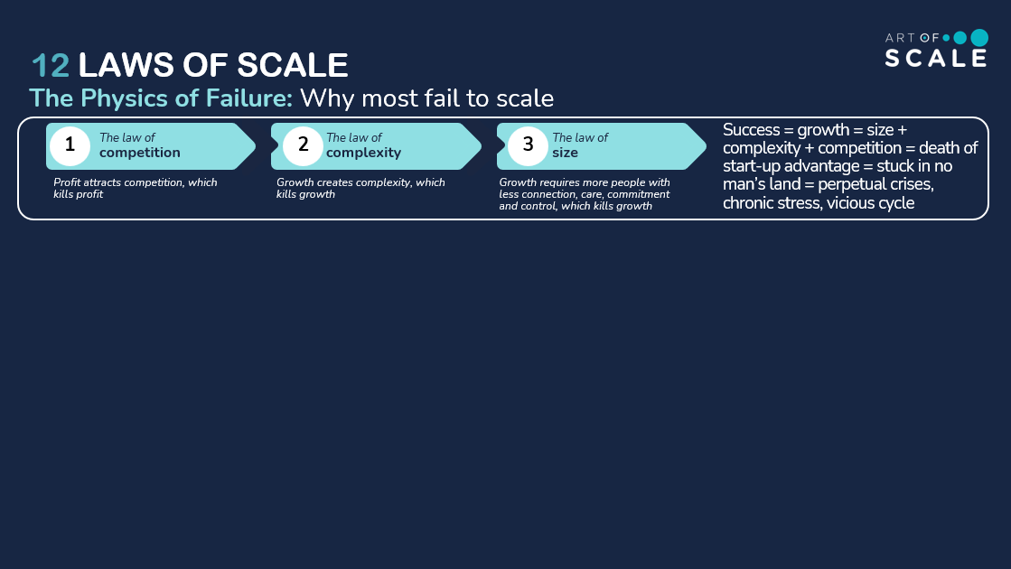

______________________________________________________________________________________________________________________________________________________________________________________________________________________________________________________________________________________________________________________________________________________________________________________________________

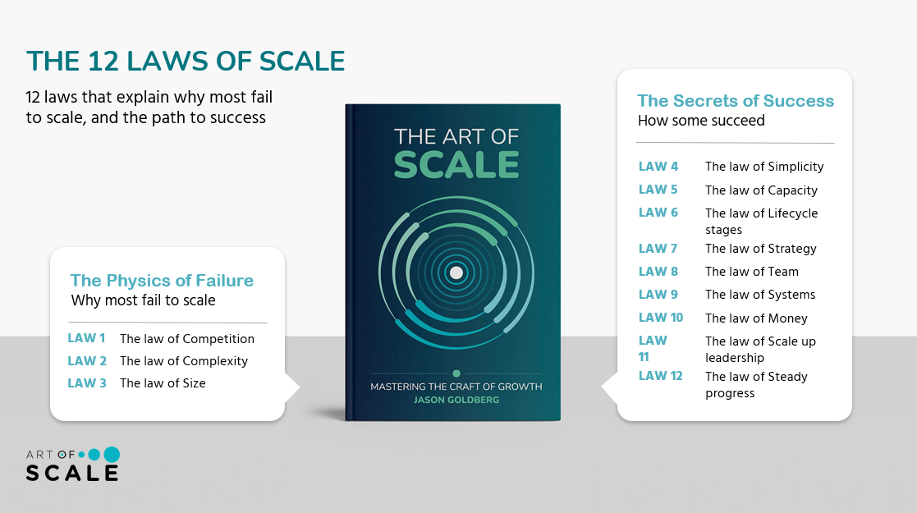

______________________________________________________________________________________________________________________________________________________________________________________________________________________________________________________________________________________________________________________________________________________________________________________________________

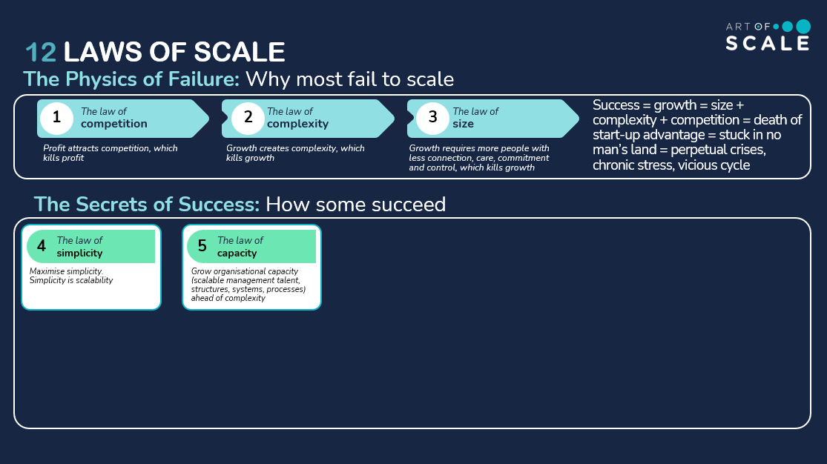

______________________________________________________________________________________________________________________________________________________________________________________________________________________________________________________________________________________________________________________________________________________________________________________________________
______________________________________________________________________________________________________________________________________________________________________________________________________________________________________________________________________________________________________________________________________________________________________________________________________

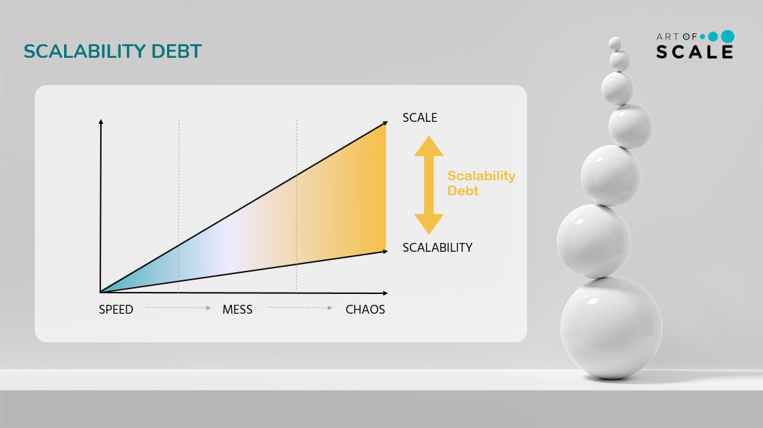
______________________________________________________________________________________________________________________________________________________________________________________________________________________________________________________________________________________________________________________________________________________________________________________________________

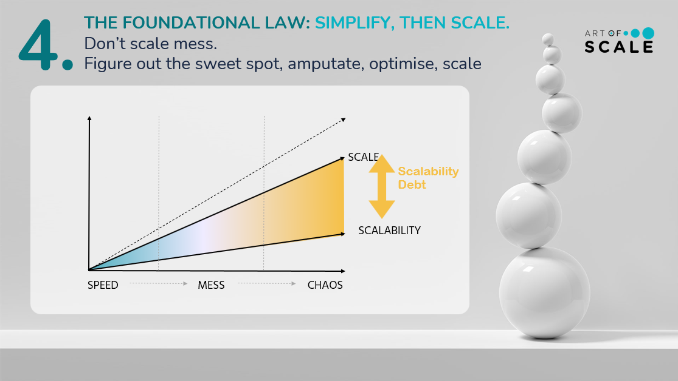

______________________________________________________________________________________________________________________________________________________________________________________________________________________________________________________________________________________________________________________________________________________________________________________________________

______________________________________________________________________________________________________________________________________________________________________________________________________________________________________________________________________________________________________________________________________________________________________________________________________

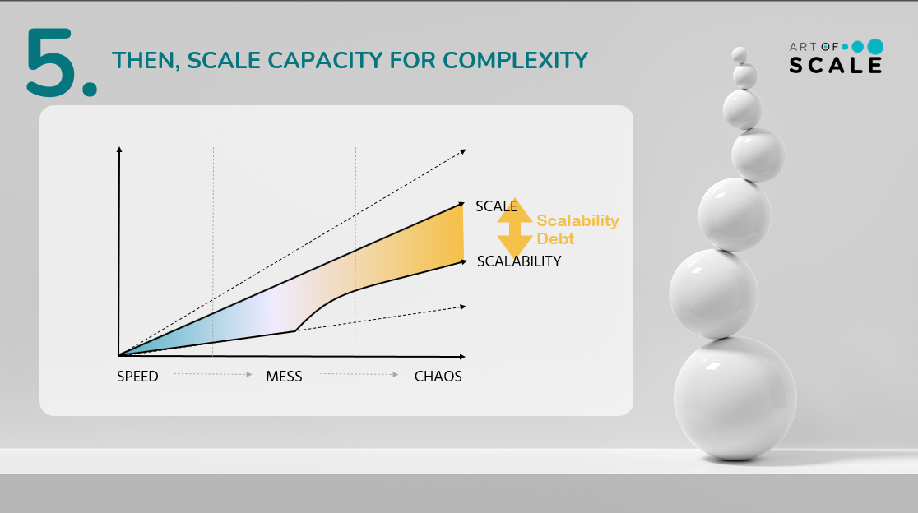
______________________________________________________________________________________________________________________________________________________________________________________________________________________________________________________________________________________________________________________________________________________________________________________________________

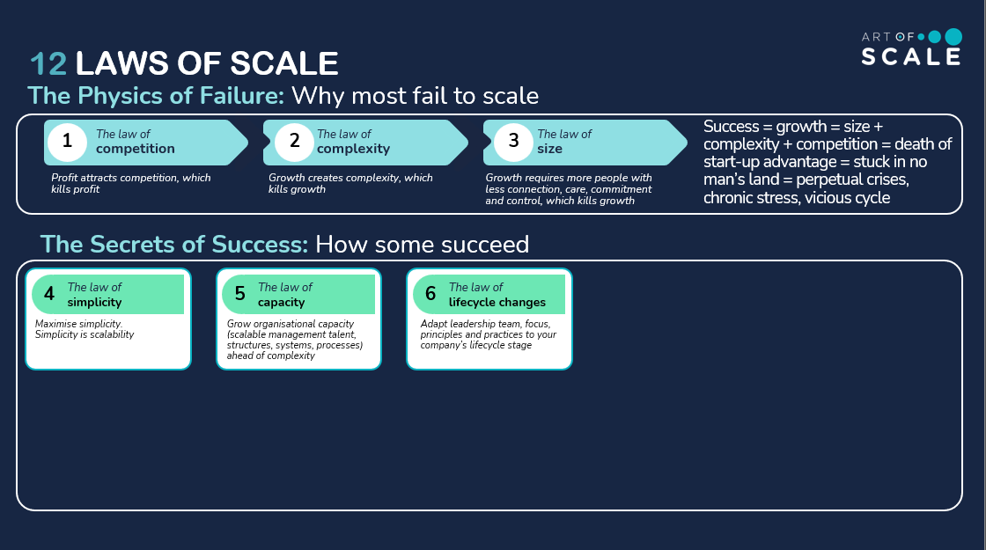

______________________________________________________________________________________________________________________________________________________________________________________________________________________________________________________________________________________________________________________________________________________________________________________________________
______________________________________________________________________________________________________________________________________________________________________________________________________________________________________________________________________________________________________________________________________________________________________________________________________

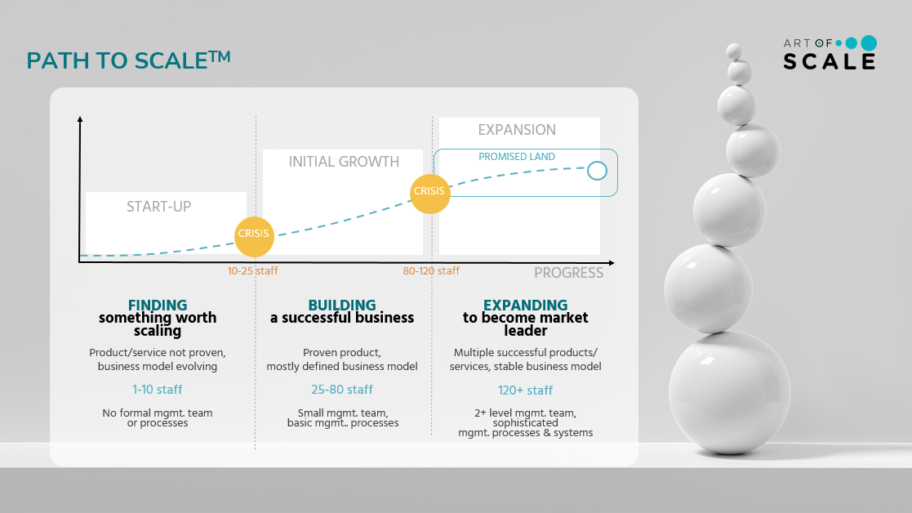

______________________________________________________________________________________________________________________________________________________________________________________________________________________________________________________________________________________________________________________________________________________________________________________________________
______________________________________________________________________________________________________________________________________________________________________________________________________________________________________________________________________________________________________________________________________________________________________________________________________

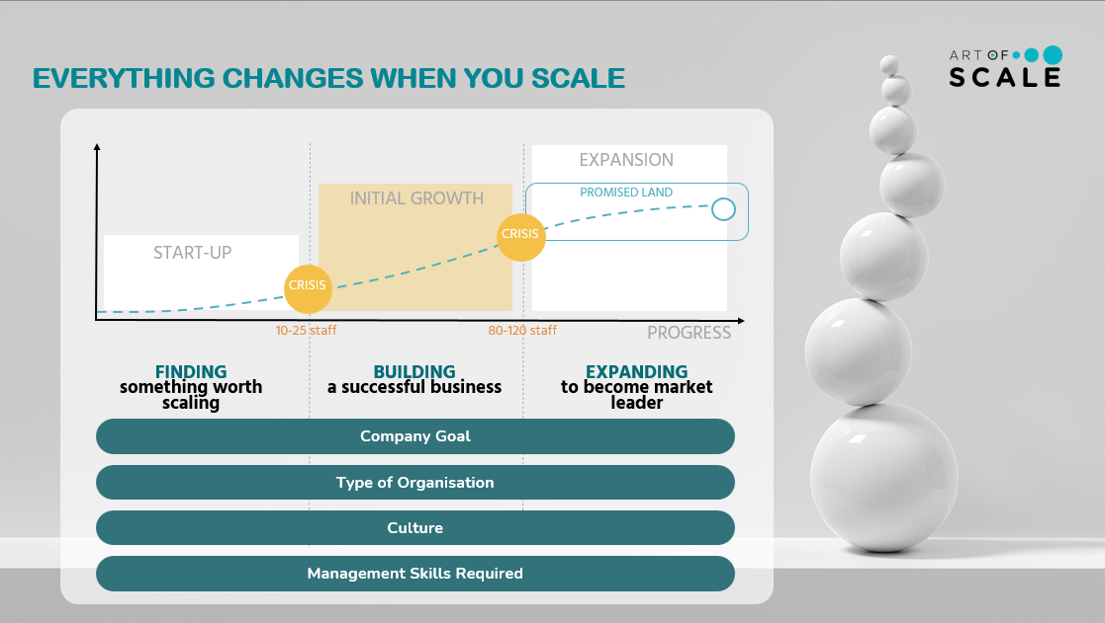

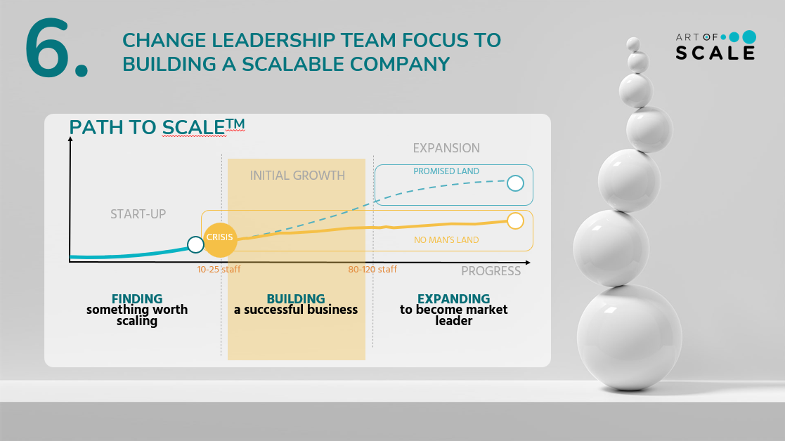

______________________________________________________________________________________________________________________________________________________________________________________________________________________________________________________________________________________________________________________________________________________________________________________________________

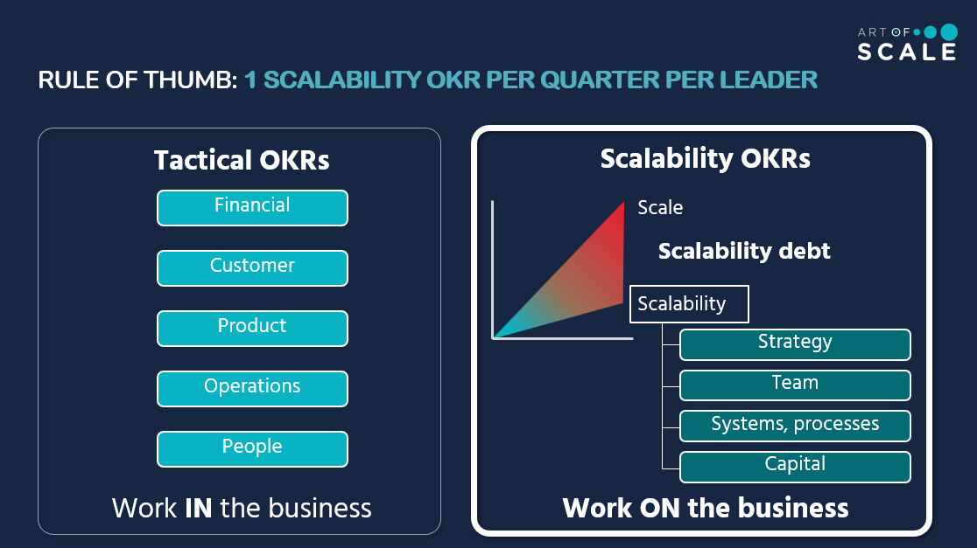

______________________________________________________________________________________________________________________________________________________________________________________________________________________________________________________________________________________________________________________________________________________________________________________________________

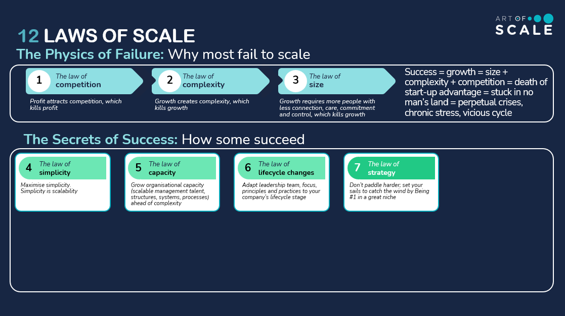

______________________________________________________________________________________________________________________________________________________________________________________________________________________________________________________________________________________________________________________________________________________________________________________________________

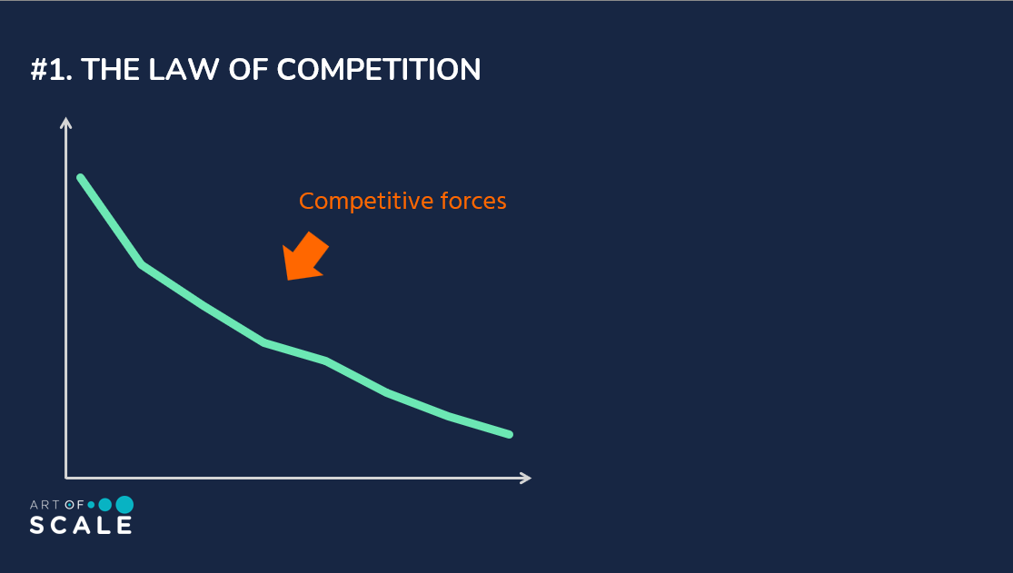

______________________________________________________________________________________________________________________________________________________________________________________________________________________________________________________________________________________________________________________________________________________________________________________________________

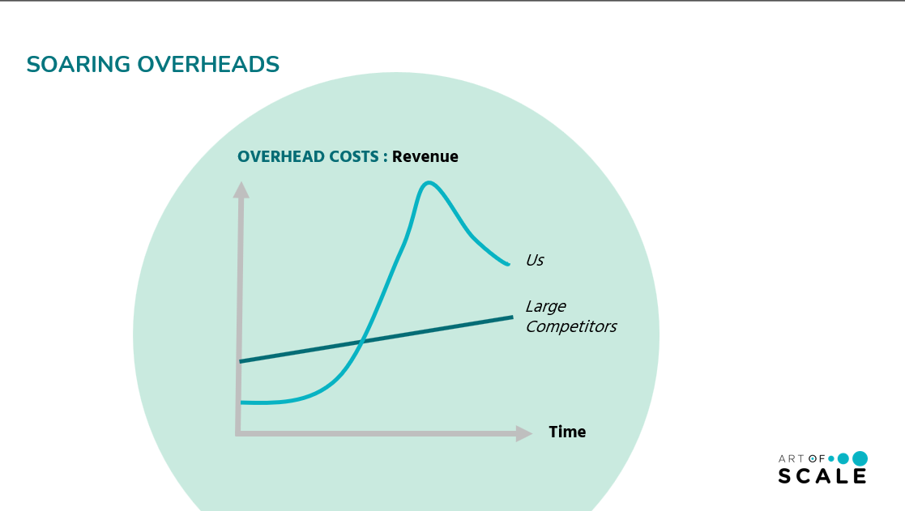

______________________________________________________________________________________________________________________________________________________________________________________________________________________________________________________________________________________________________________________________________________________________________________________________________

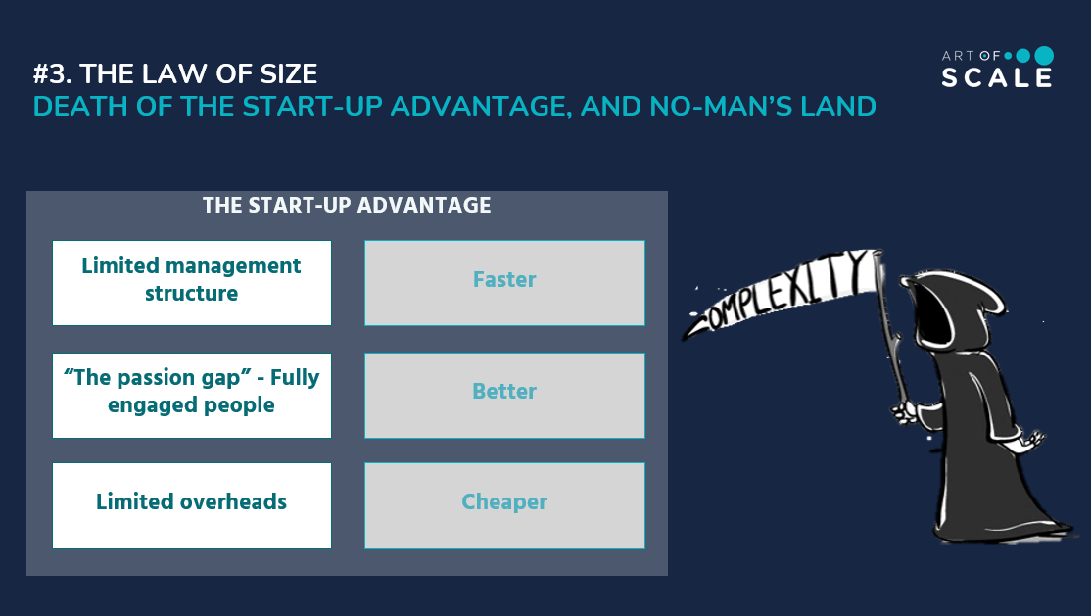

______________________________________________________________________________________________________________________________________________________________________________________________________________________________________________________________________________________________________________________________________________________________________________________________________

______________________________________________________________________________________________________________________________________________________________________________________________________________________________________________________________________________________________________________________________________________________________________________________________________

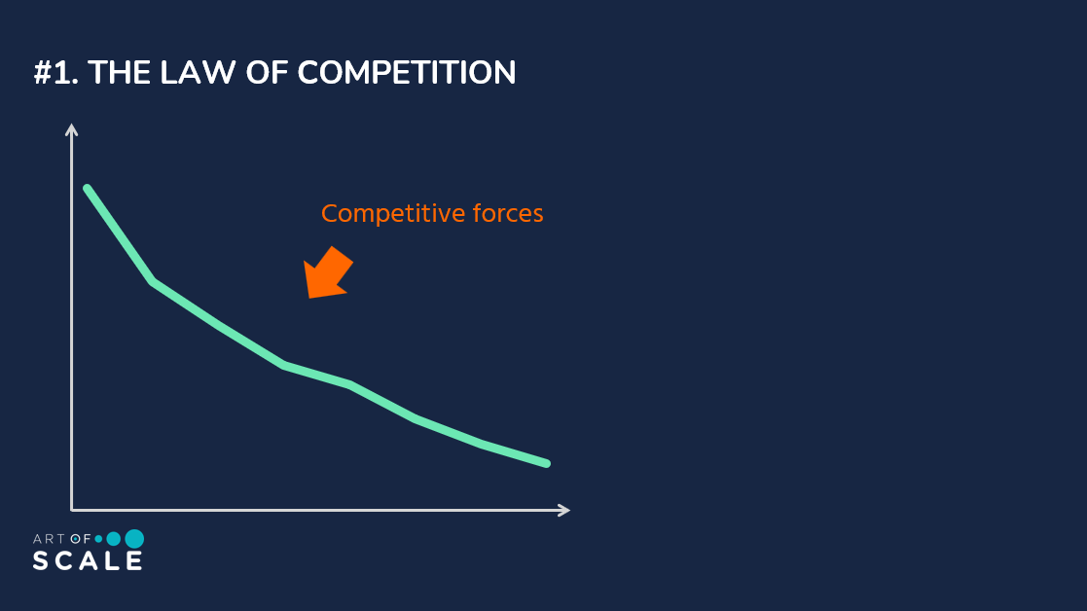

______________________________________________________________________________________________________________________________________________________________________________________________________________________________________________________________________________________________________________________________________________________________________________________________________

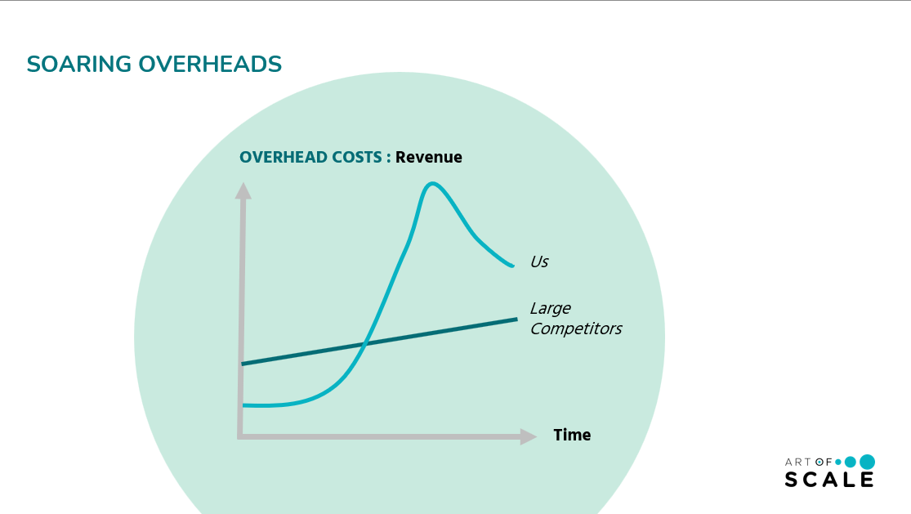

______________________________________________________________________________________________________________________________________________________________________________________________________________________________________________________________________________________________________________________________________________________________________________________________________

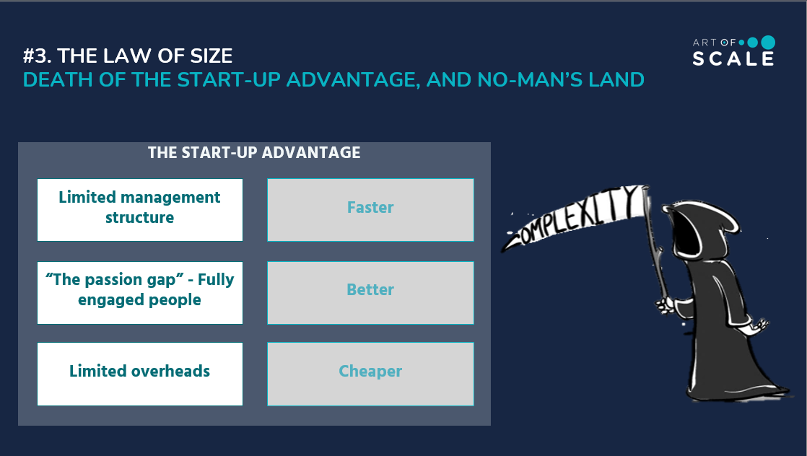

______________________________________________________________________________________________________________________________________________________________________________________________________________________________________________________________________________________________________________________________________________________________________________________________________

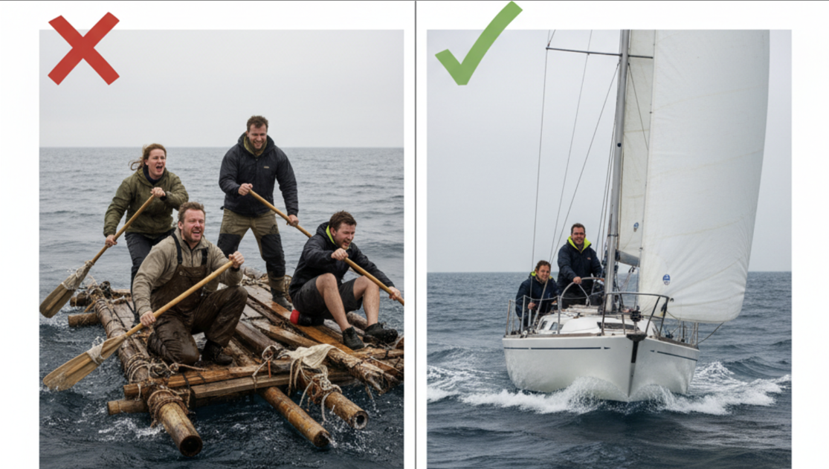
Z

______________________________________________________________________________________________________________________________________________________________________________________________________________________________________________________________________________________________________________________________________________________________________________________________________






