AI STRATEGY LAB
──────────
Future-Proofing Your Business in the Age of AI
A 60-Minute Hands-On Workshop
Participant Workbook

The Art of Scale | SHIFTAI

Session Overview
You have 60 minutes. You will leave with real strategic insight about your own business — not just AI awareness. Every exercise produces output you keep.

Session Flow
TIME | PHASE | ACTIONS
0–5 min | 1. Setup & Context | - Complete the company context template (pre-loaded). 5 fields + optional voice note.
5–10 min | 2. Deep Research kick off | - Paste Deep Research prompt into Kimi K2. Close tab — it runs in background (10–15 min).
10–15 min | 3. 3x Experts Setup | - Pick 3 experts from panel. Paste Expert Panel prompt with company context. Run it.
15–35 min | 4. 3x Experts Read & Reflect | - Read the 3 expert opinion pieces. Capture insights on the reflection sheet.
35–50 min | 5. Deep Research Review | - Return to Kimi K2 tab. Review the AI Disruption Deck and research output. Note surprises and confirmation.
50–60 min | 6. Synthesis & Homework | - Complete Strategic AI Stance one-pager.  - Decide 1 next step within 14 days

HOW THIS WORKBOOK WORKS
- Work through the pages sequentially — each step builds on the last.
- You'll capture all your outputs directly in this workbook. Your main takeaway page is on Page 14 (the last page).
- You'll need a brief company context description. If you already have one, copy and paste it in. If not, you'll create one in Step 0. This context gets pasted into both prompts.
- You'll work across two AI tools running in parallel:
Tool | Used In | Purpose
Kimi K2.5 | Phase 2 & Phase 5 | Deep Research — runs in the background while you work
ChatGPT 5.2 or Claude Opus 4.6 | Phase 3 & Phase 4 | Expert Strategy Panel — your active working exercise
- The key sequencing trick: You kick off Deep Research on Kimi in Phase 2, then close that tab. While Kimi researches in the background (10–15 min), you run the Expert Panel exercise in Phases 3 & 4. When you return to Kimi in Phase 5, your research deck is waiting.

PHASE 1: Your Company Context
Complete this first. You will paste it into every exercise prompt.

COMPANY CONTEXT
MY COMPANY IN 60 SECONDS
1. Company name & what we do (1–2 sentences):

2. Industry / sector:

3. Customer type (who buys, why they buy):

4. How we make money (core revenue model):

5. Team size & stage (headcount, years in business, rough revenue):

6. Optional: Anything else (competitive landscape, challenges, what keeps you up at night):

TIP
Save this as a text block on your device. You’ll paste it into every prompt.
Voice note option: Record 60 seconds and let AI transcribe it into the fields above.

PHASE 2: Launch Deep Research on Kimi K2 (5 min)
Open Kimi K2 (www.kimi.com). You can do what follows in a free account of you are new to Kimi, but will need to create a profile which will take 1minute with Google Single Sign on.
In the New Chat window, select K 2.5 agent.
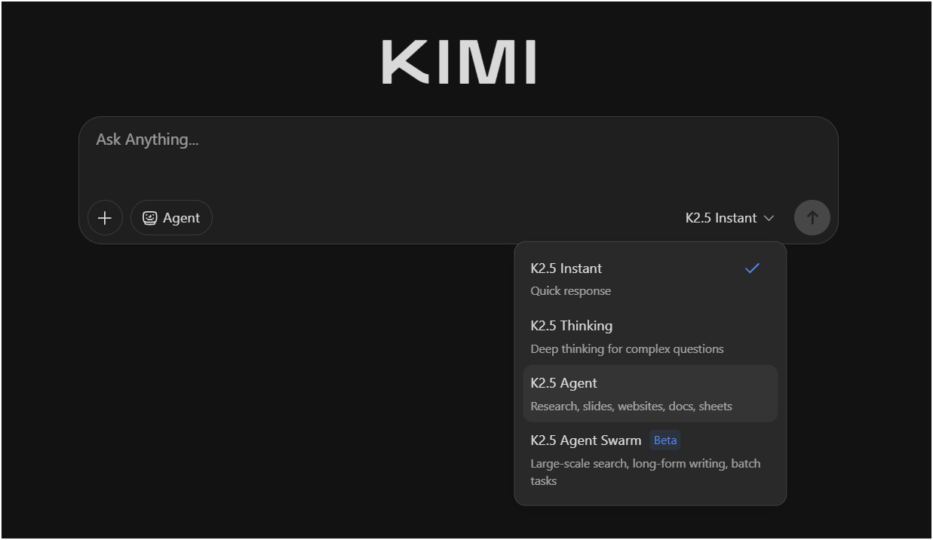
Then activate Deep Research (see below the chat bar, second button from the right)
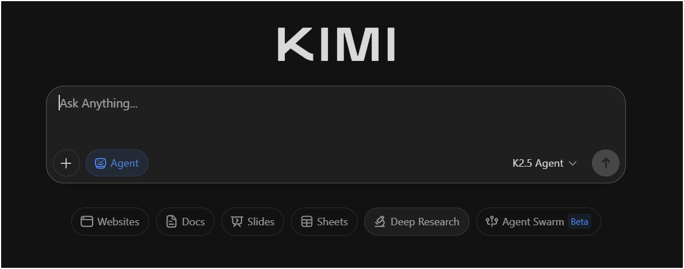
Your window should now have “Agent | Deep Research” mode activated (see below in blue font).
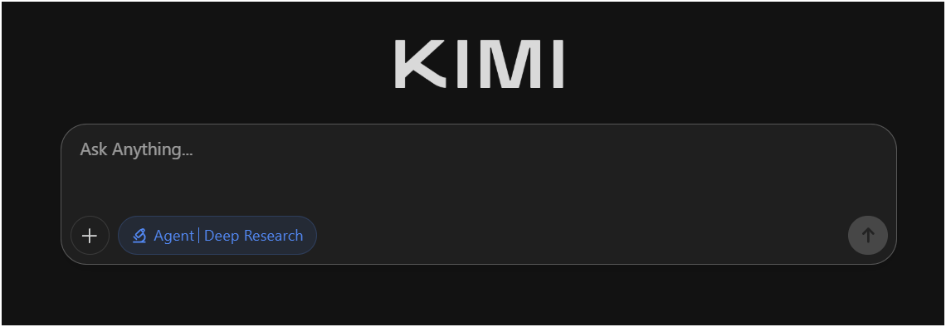

Paste Prompt 1 below with your company context. Hit enter, then close the tab and move on. This will run for c.25 minutes in the background and produce both a research briefing AND a consulting-grade visual deck.

WHY KIMI K2?
Kimi K2.5 produces exceptional, McKinsey grade slide deck output ready for Executive consumption, and its deep research output with visual presentation is also stellar.
This demonstrates how AI can compress weeks of strategy research into minutes — and deliver it presentation-ready.

Kimi K2.5 Deep Research Prompt
Copy everything below and paste into Kimi K2 with Deep Research enabled:

PROMPT 1
=== DEEP RESEARCH: AI DISRUPTION IN MY INDUSTRY ===

I am formulating strategy for the AI era. I need a picture of
how AI will change my industry/market.

Conduct a comprehensive analysis of forecast changes to my
industry/market due to AI. Explain from first principles, and
describe specific structural changes.

--- MY COMPANY CONTEXT ---
[PASTE YOUR COMPANY CONTEXT HERE]

=== PART 1: RESEARCH BRIEFING ===

Produce a decision-ready strategic intelligence brief covering:

1. INDUSTRY AI ADOPTION LANDSCAPE
- Leading AI use cases already deployed (globally)
- Competitors or adjacent players furthest ahead
- Current adoption rate among businesses my size

2. CUSTOMER EXPECTATION SHIFTS
- How customer expectations are changing because of AI
- New standards of speed, personalization, quality, or price
- Evidence of customers switching to AI-enabled alternatives

3. VALUE CHAIN DISRUPTION MAP
- Which parts of the value chain are most vulnerable
- Where costs are being driven down most aggressively
- Where new value is being created

4. EMERGING BUSINESS MODELS
- New AI-native business models in or adjacent to my industry
- Examples of businesses my size pivoting with AI

5. 12–24 MONTH OUTLOOK
- What my industry will look like in 12–24 months
- Key trigger events or tipping points to watch

Cite sources where possible. Focus on actionable intelligence.

=== PART 2: AI DISRUPTION DECK ===

Additionally, produce a professional, high-density consulting
presentation slide deck, designed in the style of a top-tier
strategy firm (McKinsey/BCG) blended with high-end editorial
aesthetics.

Core Content & Layout:
1. Rich Data Visualization: Populate with complex, precise
charts (stacked bar charts, waterfall charts, line graphs)
and detailed data tables with rows and columns.
2. Structured Frameworks: Include strategic diagrams or 2x2
matrices constructed with thin, clean lines.
3. High Information Density: Multi-column layout mimicking an
actual business analysis deck, not just a cover page.
4. Big Insights: Land paradigm-shifting insights with
breathtaking power, succinctness and clarity.

Visual Style:
1. Aesthetic: Tech-minimalist but information-heavy. Clean,
sharp, and authoritative.
2. Typography: Serif fonts (Times New Roman) for main headlines
for a premium financial report feel; clean sans-serif for
chart labels and data numbers.
3. Color Palette: Clean white background. Text is sharp black.
Charts and accents use Deep Royal Blue and distinct shades
of grey for data hierarchy.
4. Graphics: Fine hairline borders for tables and precise
vector lines for graphs.
5. Length: 15-20 slides, with a 3 slide Exec summary upfront. Format like a McKinsey deck for a Exco member who needs deep insight

=== RECOMMENDED OPPORTUNITIES AND ACTIONS ===

Based on all research, recommend 3 attractive opportunities and 3–5 highest-priority actions for a business like mine (both sets ranked by impact and ease of implementation).

Now leave this to run in the background while you move on to PHASE 3. You will review this output later.

PHASE 3: The Expert Strategy Panel
You’re about to convene a virtual panel of the world’s leading strategists to weigh in on the future of your business. Pick 3 experts. The AI will simulate each one’s perspective using their known frameworks, vocabulary, and thinking style.

Step 1: Choose Your 3 Experts
Select for diversity of viewpoint, not just familiarity. You can also name someone not on this list — the AI will simulate their perspective.

STRATEGY & COMPETITIVE DYNAMICS
1 | Michael Porter | Competitive strategy, five forces, value chains
2 | Clayton Christensen | Disruptive innovation, jobs-to-be-done
3 | Rita McGrath | Transient advantage, strategy in uncertainty
4 | Roger Martin | Integrative thinking, playing-to-win strategy
5 | Alex Osterwalder | Business model innovation, Business Model Canvas
6 | Renée Mauborgne | Blue ocean strategy, market creation
7 | Hamilton Helmer | 7 Powers, strategic power & moats
8 | Richard Rumelt | Good strategy vs. bad strategy, kernel of strategy
TECHNOLOGY, AI & DIGITAL TRANSFORMATION
9 | Andrew Ng | AI adoption, practical AI for business
10 | Ethan Mollick | Co-intelligence, AI in work & organizations
11 | Azeem Azhar | Exponential technology, industry convergence
12 | Benedict Evans | Tech disruption patterns, market shifts
13 | Satya Nadella | Enterprise AI transformation, platform shifts
14 | Sam Altman | AGI trajectory, economic restructuring
15 | Mustafa Suleyman | Applied AI, human-AI collaboration
MARKETING, BRAND & CUSTOMER
16 | Seth Godin | Permission marketing, remarkable products, tribes
17 | Gary Vaynerchuk | Attention economics, content-first strategy
18 | April Dunford | Positioning, category design
19 | Byron Sharp | Evidence-based marketing, brand growth laws
20 | Scott Galloway | Brand disruption, big tech impact on industries
OPERATIONS, SCALE & EXECUTION
21 | Verne Harnish | Scaling up, execution rhythms, cash management
22 | Patrick Lencioni | Team health, organizational clarity
23 | Jim Collins | Built to last, flywheel effects, great by choice
24 | Gino Wickman | EOS, entrepreneurial operating systems
25 | Eliyahu Goldratt | Theory of constraints, throughput focus
FINANCE, BUSINESS MODELS & VALUE CREATION
26 | Bill Gurley | Unit economics, marketplace dynamics
27 | Nassim Taleb | Antifragility, risk management, optionality
28 | Peter Thiel | Zero-to-one thinking, monopoly strategy
29 | Warren Buffett | Economic moats, long-term value creation
30 | Marc Andreessen | Software eating the world, platform economics
EMERGING MARKETS & AFRICAN ENTREPRENEURSHIP
31 | Dambisa Moyo | Emerging market economics, global trade shifts
32 | Strive Masiyiwa | African entrepreneurship, telecoms disruption
33 | Fred Swaniker | Leadership, institution-building in Africa
34 | Herman Mashaba | Bootstrapped scale-up, African consumer markets
35 | Magatte Wade | Entrepreneurship as development, African markets
INNOVATION, DESIGN & FUTURE THINKING
36 | Amy Webb | Future scenarios, strategic foresight
37 | Mariana Mazzucato | Innovation ecosystems, mission-driven strategy
38 | Steve Blank | Lean startup, customer development
39 | Ash Maurya | Lean scaling, running lean methodology
40 | Simon Wardley | Wardley mapping, value chain evolution

YOUR SELECTIONS
Expert 1: ___________________________________
Expert 2: ___________________________________
Expert 3: ___________________________________

Step 2: Run the Expert Panel Prompt
Copy everything below into Claude, ChatGPT, or Gemini. Replace the placeholders with your company context and expert names.

PROMPT 2
=== EXPERT PANEL: AI IMPACT ON MY BUSINESS ===

INSTRUCTIONS: Simulate a strategy panel. For each expert,
produce a focused opinion piece (400–600 words) answering
the questions below. Write in first person as that expert,
using their known frameworks, vocabulary, and thinking style.
Be specific to my industry — no generic AI hype. Be honest,
even uncomfortable.

--- MY COMPANY CONTEXT ---
[PASTE YOUR COMPANY CONTEXT HERE]

--- SELECTED EXPERTS ---
Expert 1: [NAME]
Expert 2: [NAME]
Expert 3: [NAME]

--- QUESTIONS FOR EACH EXPERT (answer all 5) ---

1. WHAT STAYS THE SAME
What fundamental truths about this industry and its customers
will endure regardless of AI? What should this founder keep
investing in confidently?

2. WHAT CHANGES — FIRST, SECOND & THIRD ORDER EFFECTS of AI, FOR MY BUSINESS
How will AI ripple through this industry? Think beyond the
obvious. How will customer expectations shift? How will
competitor offerings evolve? Which parts of the value chain
get compressed, eliminated, or transformed? What new entrants
become possible?

3. EXISTENTIAL RISK RATING (1–5 scale)
Rate the threat level if this business does nothing about AI:
1/5 “Steady Ship” — AI changes tools, not the game.
2/5 “Slow Erosion” — Margins compress over 2–3 years.
3/5 “Burning Platform” — Core value commoditized in 12–24mo.
4/5 “Reinvent or Retreat” — Business model under threat.
5/5 “Extinction Event” — Core offering becomes near-worthless.
Explain your rating with specifics.

4. BIGGEST OPPORTUNITIES
What new niches, services, or value propositions does AI create
for a business like this? What unmet customer needs can now
be served? What adjacent markets open up? Be concrete.

5. ONE BOLD MOVE
If you could recommend only one strategic action for the next 90 days, what would it be and why?

--- OUTPUT FORMAT ---
Present each expert’s opinion as a separate, clearly labeled
section. After all three, add a CONVERGENCE & DIVERGENCE
summary: where do the experts agree? Where do they disagree?
What tensions should I sit with?

Reference: Existential Risk Scale
1/5 | Steady Ship | AI changes the tools, not the game. Business model remains sound.
2/5 | Slow Erosion | Margins compress gradually. Competitors gain efficiency over 2–3 years.
3/5 | Burning Platform | Core value proposition commoditized within 12–24 months. Must adapt.
4/5 | Reinvent or Retreat | Fundamental business model under threat. Major pivot in 12 months.
5/5 | Extinction Event | Core offering becomes near-worthless. Think traditional copywriting, data entry.

PHASE 4: Reflect (5 minutes)
After reading all three expert opinions, capture your takeaways:

REFLECTION SHEET
1. What surprised me most? What challenged my assumptions?

2. On a scale of 1–5, how urgent is AI adaptation for my business?
Has my sense of urgency changed after reading the expert views?

3. What are the best opportunities I want to explore?

PHASE 5: Review Your Kimi K2 Deep Research (10 minutes)
Return to your Kimi K2 tab. You should now have two outputs to review:

1. The Research Briefing: Scan for surprises, confirmation of what the experts said, and data points that sharpen your view. Note the top 2–3 insights that are new or actionable.

2. The AI Disruption Deck: Review the visual presentation. This is a consulting-grade artifact you can share with your team. Note which charts or frameworks land the hardest — these are your communication tools for driving urgency internally.

THE POWER MOVE
You just produced a McKinsey-style research brief and presentation deck in 15 minutes,
while simultaneously getting expert strategic opinions on your specific business.
This is what AI-augmented strategy work looks like. The question is: what will you do with the insight?

PHASE 6: Synthesis - Your Strategic outlook
Complete this before you leave the room. This is your take away, and your strategic starting point.

ONE-PAGE STRATEGIC AI STANCE

My AI risk rating (1–5): ______

The #1 thing that will NOT change about my industry:
_____________________________________________________________

The #1 thing that WILL change in the next 12 months:
_____________________________________________________________

My 3 best AI opportunities
_____________________________________________________________
_____________________________________________________________
_____________________________________________________________

My biggest AI vulnerability:
_____________________________________________________________

One action I will take in the next 2 weeks:
_____________________________________________________________

One thing I will stop doing now, to make room to prioritise strategy:
_____________________________________________________________

